PÀ£ÁðlPÀ ¸ÀPÁðgÀ
PÁ¯ÉÃdÄ ²PÀët E¯ÁSÉ
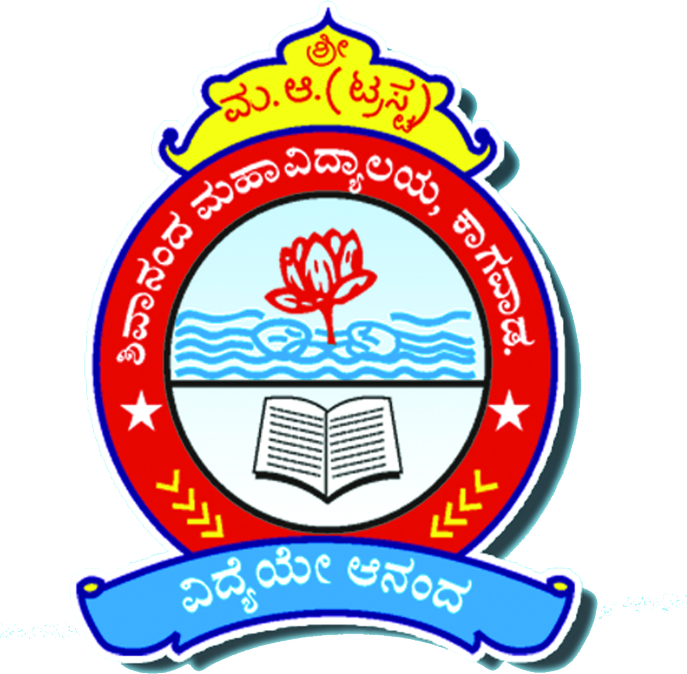

SHIVANAND COLLEGE KAGEWAD
.Dist. Karnataka

ACADEMIC CALENDAR
For the year 2022-2023

Prepared by
Internal Quality Assurance Cell

Annexure-01
List of mandatory activities as per the requirement of Assessment and Accreditation (A&A) of NAAC. The IQAC must incorporate these in their final Calendar of Events along with other Institutional level academic and other activities in adherence to respective Universities Calendar of Events (CoE)
Sl. No | NAAC Metrics | Activity/ies | NAAC Weightage | Odd/Even | Week and month/ Action Taken / Remarks
1 | General | Principal’s Meeting with H.O.D & staff for formation of committees & action plan | - | Odd | 1st day of Reopening
2 | General | Induction/orientation/ Inaugural Programme for First Year Students | -- | Odd | 1st Week of reopening
3 | General | Preparation of Timetable | - | Both | First week of the semester
4 | 1.1.2 | Preparation of Calendar of Events | 05 | First week of the Odd semester
5 | 1.2.2 | Add on/Certificate Courses* | 10+ 10 | Both | First Three months of the Semester
6 | 1.3.1 | Crosscutting Issues- Special Lectures on Ethics, gender, Human Values, Environment and Sustainability | 10 | Even | Fourth week of 1st Month
7 | 1.4.1 | Stakeholders Feedback | 10+10 | Even | First Week of 4th Month
8 | 2.3.3 | Awareness session on Mentor Programme and its advantages | 15 | Odd | Second week of First month
9 | 2.5.1 | IA Assessment | 15+15 | As per University guidelines and CoE
10 | 2.6.3 | Result analysis and action plan by description & upload to website | 30 | Both | Within 02 weeks from the release of result sheets**
11 | 3.1.3 | Seminar/ Conference/Workshop | 05 | Both | At least 01 each in a year to be conducted
12 | 3.3.1 | Extension Activities - Street Play, Jatha, Human-Chain by NSS/NCC/Red-cross, Scout and Guides/NGO and NSS annual special Camp | 10+10+20+20 | Both | Colleges can collaborate with NGOs, industries, Govt. Departments for support.
13 | 5.1.3 | One-week programme on soft Skill, Language and Communication Skill, ICT/Computer skills | 10 | Both | One-week programme(covering all four skill) for each semester. (afternoon)
14 | 5.1.4 | Guidance programme on various competitive exams | 10 | Both | Continuous activities (as and when notifications are out) by Placement Cell
15 | 5.1.5 | Sensitization on Prevention of Sexual harassment cell & Anti Ragging cell | 05 | Odd | Beginning of the semester
16 | 5.2.1 | Pre-Placements Training, Guidance & Counselling | 10 | Both | For final year students
17 | 5.2.1 | Placements Drive |  | Both | For final year students
18 | 5.3.3 | Sports, Cultural and competitions | 20 | Both | As per University Sports and Cultural COE
19 |  | Sports and Cultural Day |  | Even | First week of last Month
20 | General | Valedictory programme | Last month of Even semester
21 | 5.4.1 | Alumni meet once in a year | 05+05 | Even | First week of second month
22 | 5.4.2 | Seminar or Talk by Alumni for students |  | Both | (at least two in a year or one in a semester)
23 | 6.3.5 | Academic Audit | 05 | Even | First week of last month
24 | 6.5 | IQAC Meeting  (Twice in a semester) | 10+10+10 | Both | Begging and End of Each semester
25 | 6.5.3 | Preparation & upload of AQAR Reports | 10 | As per NAAC guidelines
26 | 7.1.6 | Stock verification | 05 | Even | Second week of last month
27 | General | Parent Teachers Meeting | -- | Both | After the release of Odd/ Even semester results
28 | General | Two CDC meetings | - | Both | One in each semester

* Students of 3rd and 5th semesters must register for MOOC courses on SWAYAM or any other suitable UGC recognized platforms. https://docs.google.com/spreadsheets/d/e/2PACX-1vTDp7Tc1jHmOcE82rml9Fj1wgdERMb8yMMyUMZC6B2I1VOVO8zt-
**Result analysis to be prepared for each Programme (B.Com, BBA/BBM) and Course (BA, B.Sc - Subject wise) as per Grade wise/ Class
Total number of students | Appeared | Absent | FCD*** | First Class | Second Class | Pass Class | Fail | Pass percentage
*** FCD= First Class with Distinction

Annexure-02
ACADEMIC CALENDAR |  |  | 2022-2023
Month |  | Activities
September 2022 | List of Activities and Date |  |  |  | Action Taken / Remarks
 | 1/June 2022 |  |  |  | Admission Notification
 | 10/June 2022 |  |  |  | Admission for UG Courses Online application through student portal
 | First Week of the Semester |  |  |  | Preparation of Time Table
 | Induction programme
 | 5/9/2022 Day celebration |  |  |  | Dr. S. Radhakrishnans Birth Day as Teachers Day
 | 24/9/2022 NSS day |  |  |  | To create awareness of social service National service, cleanliness etc
 | 27/9/2022 Vishwakarma Diwas |  |  |  | To create Traditional Skills and stiffness
ACADEMIC CALENDAR |  |  | 2022-2023
Month |  | Activities
October 2022 | List of Activities and Date |  |  |  | Action Taken / Remarks
 | 2/10/22 Day/Birth Anniversary |  |  |  | Gandhiji and Lal Bahadur Jayanti
 | Add on/Certificate Courses |  |  |  | First Week
 | Guidance Programme on various competitive exams |  |  |  | 3rd week of the month
 | Ist Internal Test |  |  |  | After 8th Week of Commencement of Semester
 | 8/10/2022 |  |  |  | Valmiki Jayanti
ACADEMIC CALENDAR |  |  | 2022-2023
Month |  | Activities
November 2022 | List of Activities and Date |  |  |  | Action Taken / Remarks
 | 1/11/2022 Celebration |  |  |  | Karnataka Rajyostva
 | 26/11/2022 Day Celebration |  |  |  | National Constitution Day
 | 28/11/2022 Day Celebration |  |  |  | N.C.C
 | 30/11/2022 Birth Anniversary |  |  |  | Kanakdas Jayanti
 | Preparation and upload AQAR Reports |  |  |  | 3rd and 4th Week
 | Awareness Programmes and Jattha |  |  |  | Health and Hygiene
 | Second Test( Internal Test) |  |  |  | After 12th Week
ACADEMIC CALENDAR |  |  | 2022-2023
Month |  | Activities
December 2022 | List of Activities and Date |  |  | Action Taken / Remarks
 | 1/12/22 Day Celebration |  |  | Worlds Aids Day
 | 10/12/22 Human Rights Awareness Programme |  |  | Worlds Human Right Day
 | Pratibha Puraskar for Meritorious Students |  |  | 2nd Week
 | Extension Activities |  |  | Awarness Jaatha,(Aids Anti Ragging, tobacco etc)
 | Seminar Workshop
 | Alumni Meet |  |  | Last week
 | Result Analysis and action plan by description and upload to website |  |  | After decalaration of Results
 | Parents Teachers Association |  |  | Last Week
ACADEMIC CALENDAR |  |  | 2022-2023
Month |  | Activities
January 2023 | List of Activities and Date |  |  |  |  | Action Taken / Remarks
 | 12/01/2023 Birth Anniversary |  |  |  |  | Swamy Vivekanand
 | 12/01/2023 to 18/01/2023 Youth Week Observation |  |  |  |  | Debate, Speech, Painting, Rangoli Completion’s on life and teachings of Swami Vivekanand
 | 14/01/2023 Traditional Day |  |  |  |  | Makar Sankranti
 | Seminar/Workshop/Conference |  |  |  |  | 2nd week of January
 | Awareness Programme |  |  |  |  | Anti Drug/Alcholol absue
 | Skill Oriented/Enhancement-Programme |  |  |  |  | Third Week
 | 23/01/2023 Birth Anniversary |  |  |  |  | Netaji Subhas Chandra Bose
 | 25/01/2013 Awareness Programme |  |  |  |  | Observation of National Voters Day
 | 26/01/2003 National Festival |  |  |  |  | Observation of Republic Day
 | Competitive Exam Guidance Programme |  |  |  |  | Last week of the Month
 | Pre-Placement Training , Guidance and Counselling |  |  |  |  | Last week of the month

ACADEMIC CALENDAR |  |  |  | 2022-2023
Month |  | Activities
Feb 2023 | List of Activities and Date |  |  |  | Action Taken / Remarks
 | 19/01/2023 Birth Anniversary |  |  |  | Observation of Shivaji Jayanti
 | Lecture series as per MOUs |  |  |  | Departmental Lecture Series as per tie up with the different Institutions- Third week of the Month
 | Tour/ Visits |  |  |  | Departmental-Study Tours, Industrial/Jail/Historical places Last week of the Month
 | 28/02/2023 Day Celebration/Exhibition |  |  |  | Science-Day Exhibition
ACADEMIC CALENDAR |  |  |  | 2022-2023
Month |  | Activities
March 2023 | List of Activities and Date |  |  |  | Action Taken / Remarks
 | 8/3/2023 Day Celebration |  |  |  | International Womens Day
 | One Week Programme on Communication & Computer for staff |  |  |  | Last Week
ACADEMIC CALENDAR |  |  |  | 2022-2023
Month |  | Activities
April 2023 | List of Activities and Date |  |  |  | Action Taken / Remarks
 | Placement Drive and Guidance |  |  |  | Ist Week
 | Add-on/Certificate course |  |  |  | Ist Week
 | NSS Annual Special Camp |  |  |  | 2nd Week
 | 14/04/2023 – Birth Anniversary |  |  |  | Dr. B. R. Amedkar Jayanti
 | Blood Donation Camp |  |  |  | 3rd Week
ACADEMIC CALENDAR |  |  |  | 2022-2023
Month |  | Activities
May 2023 | List of Activities and Date |  |  |  | Action Taken / Remarks
 | Alumni –Meet |  |  |  | 1st Week
 | 3/5/2023 –Birth Anniversary |  |  |  | Basaveshwar Jayanti
 | Workshop/Seminar/Conference |  |  |  | 3rd Week
 | One-Week Programme on Soft-Skills |  |  |  | Last Week
 | Training & Guidance on Competitive Exams |  |  |  | Last Week
ACADEMIC CALENDAR |  |  |  | 2022-2023
Month |  | Activities
June 2023 | List of Activities and Date |  |  |  | Action Taken / Remarks
 | 5/6/2023 Day Celebration |  |  |  | Worlds Environment & Human Values
 | Placement Drive |  |  |  | 2nd Week
 | Workshop/Seminar/Conference |  |  |  | 2nd or 3rd Week
 | 20/6/2023 Day Celebration |  |  |  | Founders Day(College Founders Day)
 | 21/6/2023 Day Celebration |  |  |  | Inernational Yoga-Day
 | Alumni Meet |  |  |  | Last week
ACADEMIC CALENDAR |  |  |  | 2022-2023
Month |  | Activities
July 2023 | List of Activities and Date |  |  |  | Action Taken / Remarks
 | Feedback |  |  |  | 1st Week
 | PTA-Meet(Alumni Talk) |  |  |  | 1st week
 | Internal Test |  |  |  | 8th Week of commencement of Even sems
 | Valedictory -Programme Annual Fest & Gymkhana Day |  |  |  | Last Week
 | IQAC Meeting |  |  |  | Last Week
ACADEMIC CALENDAR |  |  |  | 2022-2023
Month |  |  | Activities
August 2023 |  |  | List of Activities and Date |  | Action Taken / Remarks
 |  |  | Result Analysis, Action Plan and uploading to website Program(Annual Fest & Gymkhana day |  | Ist Week
 |  |  | Day-Celebration National Festival |  | Independence Day
 |  |  | Day Celebration(Sports-Day) |  | National-Sports Day Celebration Hockey-Legend-Dhyan Chand’s Birth Anniversary
 |  |  | Stock –Verification |  | Last Week

